SIMULATION TASK – REPORT

COURSE OUTCOME – CO3 | ASSESSMENT TASK – AT2

INTRODUCE HAZARDS IN A COMBINATIONAL PART OF A SEQUENTIAL CIRCUIT AND SIMULATE GLITCH BEHAVIOR.

NAME : VISHAL P
REGISTER NO. : 192512340
COURSE CODE : ECA0202
COURSE : DIGITAL CIRCUITS
FACULTY :DR. J MOHANA

Software Used: Xilinx Vivado 2026.1
HDL: Verilog HDL
Device: Artix-7 — xc7a12ticsg325-1L

AIM
To introduce a hazard in the combinational part of a sequential circuit and simulate the resulting glitch behavior using Verilog HDL in Xilinx Vivado.
OBJECTIVES
- To understand the concept of hazards in combinational circuits.
- To design a combinational circuit that produces a temporary glitch due to unequal propagation delays.
- To write and simulate the circuit using Verilog HDL in Vivado.
- To observe the input and output waveforms during signal transitions.
- To identify and analyze the hazard/glitch in the simulated output.
VERILOG CODE
hazard-circuits.v

`timescale 1ns/1ps

module hazard_circuit(
input A,
input B,
input C,
output Y
);
wire nA;
wire term1;
wire term2;

not #(2) U1(nA, A);
and #(5) U2(term1, A, B);
and #(1) U3(term2, nA, C);
or #(2) U4(Y, term1, term2);

endmodule
TESTBENCH CODE
hazard_circuit_tb.
`timescale 1ns/1ps

module hazard_circuit_tb;

reg A;
reg B;
reg C;
wire Y;

hazard_circuit DUT (
.A(A),
.B(B),
.C(C),
.Y(Y)
);

initial begin
B = 1;
C = 1;
A = 0;

#20;
A = 1;

#20;
A = 0;

#20;
$finish;
end

Endmodule

SIMULATION PROCEDURE
Procedure
- Open Xilinx Vivado 2026.1 and create a new RTL Project.
- Create a Verilog design source and define the required inputs and output.
- Write the Verilog code for the combinational circuit with different propagation delays to introduce a hazard.
- Add a simulation source (testbench) to provide suitable input combinations and transitions.
- Save and check both the design module and testbench for syntax errors.
- Select Simulation → Run Simulation → Run Behavioral Simulation.
- Add the required signals such as A, B, C, and Y to the waveform window.
- Run the simulation and observe the input and output waveforms.
- Zoom into the transition region and identify the temporary unwanted change in the output (glitch/hazard).
- Record the waveform and verify the hazard behavior caused by unequal propagation delays.

SIMULATION OUTPUT
Output Waveform
The simulation output shows the combinational circuit producing a temporary glitch (hazard) during the input transition:
A: 0 → 1 → 0
B: 1 → 1 → 1
C: 1 → 1 → 1
Y: 1 → 0 → 1 → 0 → 1
The temporary unwanted transition in Y represents the hazard/glitch behavior caused by unequal propagation delays.

OUTPUT SCREENSHOT:

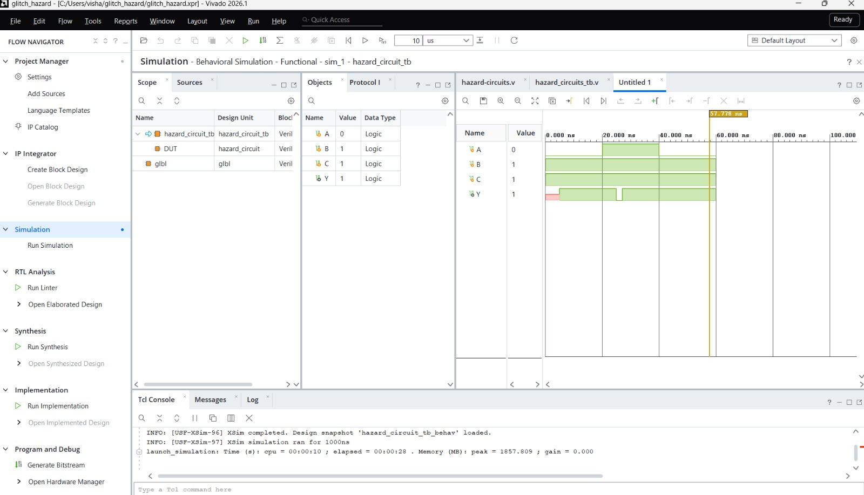

RESULT
The combinational circuit was successfully designed and simulated in Xilinx Vivado. The simulation waveform showed a temporary unwanted glitch (hazard) during input transitions due to unequal propagation delays. Thus, the hazard and glitch behavior were successfully observed and verified.

CONCLUSION
The hazard in the combinational circuit was successfully introduced and simulated using Verilog HDL in Xilinx Vivado. The output waveform clearly demonstrated the temporary glitch caused by unequal propagation delays, helping to understand the effect of hazards in digital circuits.

